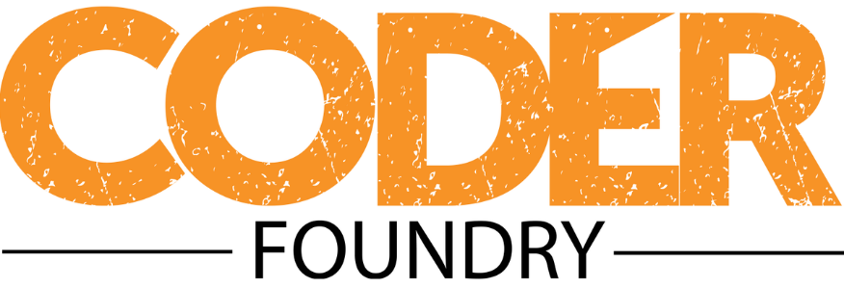

# Project Deliverables

## Part #1

### Project

Blog

Project-right key -pulish

### Requirements

□ Use an appropriate Bootstrap template for a professional appearance

□ Make sure you validate all user inputs.

□ Post Class modeled with the following fields (Make sure you include fields required by EntityFramework)

□ Title

□ Body

□ Published (Boolean)

□ Date created

□ Date updated

□ User

□ Working pages/functionality

□ Create/Edit Posts – Page to input information to create or edit posts. TinyMCE and File upload must be included in the page.

□ List Posts – Page to list all posts. This page can display additionally functionality/buttons based on user role. This page will not display the full details of the post.

□ Delete Posts – Page or button to delete posts

□ View Post – Page used to display the full details of the post

□ Security

□ Database Seeded Login for Admin Role

- Username: [admin@blog.com](mailto:admin@blog.com)

- Password: Password-1

□ Database Seeded Login for Moderator role

- Username: [moderator@blog.com](mailto:moderator@blog.com)

- Password: Password-1

□ Admin authorization required for blog post maintenance (Create/Edit/Delete)

### Sample Site:

https://zhengblog.azurewebsites.net

### Due Date

Wednesday, March 13th, 2019 at 8:45